III. Another mass grave with four remains was found in Edilli on October 15-27, 2022. The investigation for the identification is under way.
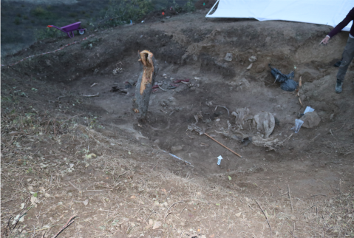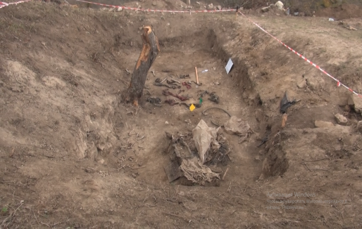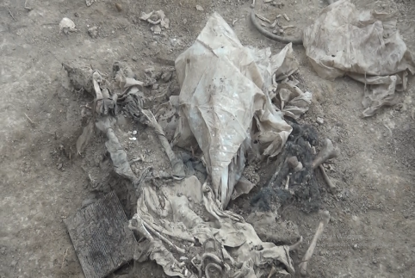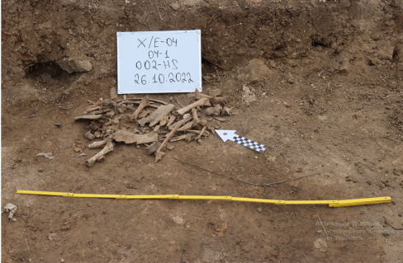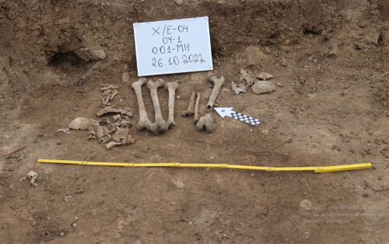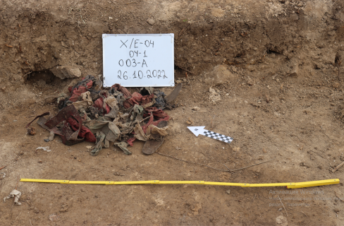
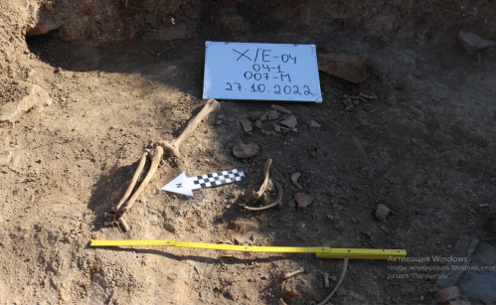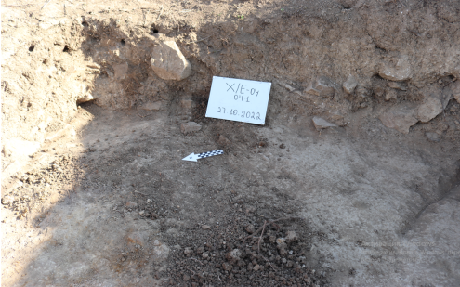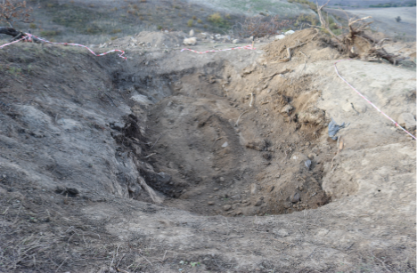

Mass graves in Farrukh village of Khojaly district
The Office of Military Prosecutor of the Republic of Azerbaijan has started an investigation in relation to the mass burial site found in the territory of Farrukh village of Khojaly district. The mass grave was discovered on March 28-29, 2022, during the road construction works in the area. 12 remains belonging to 5 men, 5 women and 2 children were discovered in the site. A forensic investigation was conducted to find out the reason of death. The identification of personality is carried out by the Forensic Research Department of the Ministry of Interior Affairs.
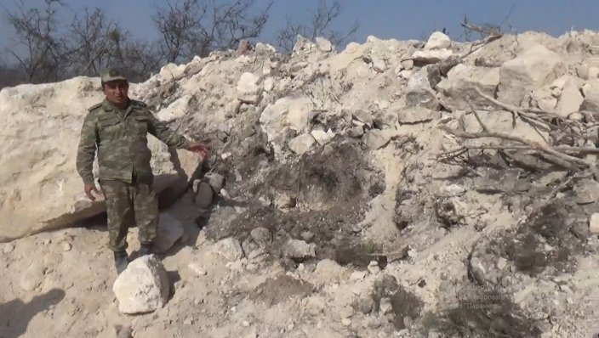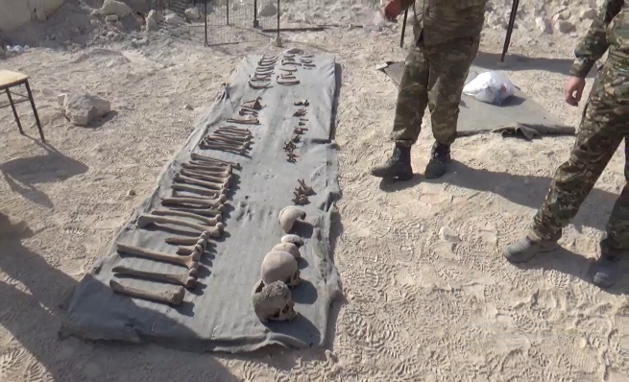

Mass graves in Dashalty village of Shusha district
On February 17, 2021, the servicemen of the Ministry of Defense of the Republic of Azerbaijan exhumed 11 remains belonging to men and 17 remains also belonging to men from two different mass graves found in the territory of the Dashalty village of Shusha district. The Office of Military Prosecutor of the Republic of Azerbaijan has started a criminal case in relation of the mass graves in Dashalty village. The molecular-genetic and forensic expertise of the remains is under way.

Given the extreme importance of addressing the issue of missing persons for the rule of law, justice, as well as post-conflict normalization and reconciliation, the strong engagement of the international community, especially Armenia is vital. With the end of the conflict, it is high time for Armenia to honour its obligations under international humanitarian law and take practical steps to shed light on the dark pages of its armed aggression against Azerbaijan and cooperate with a view to eliminating its harsh consequences. The families of missing persons still expect that Armenia will share all information at its disposal necessary for bringing clarity to the fates of thousand s of persons missing since the early 1990s, as well as the information about the mass graves.

